**Grumpy Cat™ Token Whitepaper**

**Abstract:**

Grumpy Cat is poised to redefine the cryptocurrency landscape with a unique tokenomics model, emphasizing community engagement, liquidity, sustainable growth, and the integration of decentralized governance through a DAO. Additionally, we aim to seamlessly incorporate decentralized finance (DeFi) protocols into our ecosystem. This whitepaper details the core features, token distribution strategy, use cases, governance through DAO, and a comprehensive roadmap for the Grumpy Cat token. The roadmap includes utility wallet and blockchain explorer development, marketing initiatives, airdrop campaigns, and strategic integration of DeFi functionalities.

**Introduction:**

Grumpy Cat transcends the traditional crypto project. It's a community-driven initiative that combines a whimsical theme with robust tokenomics. Our mission is to cultivate innovation, inclusivity, and financial empowerment within the crypto space.

**Tokenomics:**

Total Supply: 100,000,000,000 Billion Grumpy Cat Tokens  
  
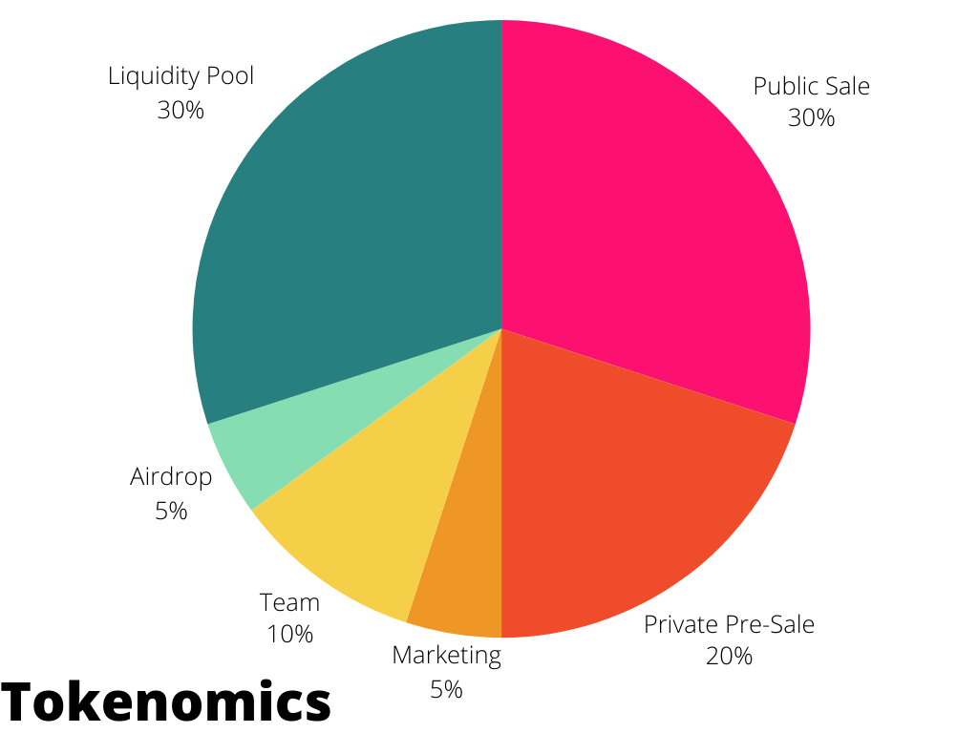  
Public Sale (30%): A transparent approach to token distribution, encouraging a diverse audience to actively participate in and contribute to the Grumpy Cat ecosystem.

Private Pre-Sale (20%): Reserved for early supporters and investors, providing exclusive access to engage in the project's development.

Liquidity Pool (30%): A significant allocation dedicated to a liquidity pool, ensuring stability and facilitating seamless trading across various platforms.

Team (10%): Allocated to the development team as an incentive, recognizing and motivating their commitment to the project's success.

Marketing (5%): Directed towards promotional activities, creating awareness, and building a vibrant community around Grumpy Cat.

Airdrop (5%): Reserved for airdrop campaigns, distributing tokens to a selected audience to stimulate wider adoption and community growth.

**Use Cases:**

Grumpy Cat tokens serve various roles within the ecosystem:

Voting rights on governance decisions through the DAO, ensuring a democratic approach to critical project decisions.

Access to exclusive features and content, enhancing the overall user experience.

Rewards for liquidity providers, incentivize users to contribute to the liquidity pool.

Incentives for the development team, aligning their interests with the project's success.

**Roadmap:** 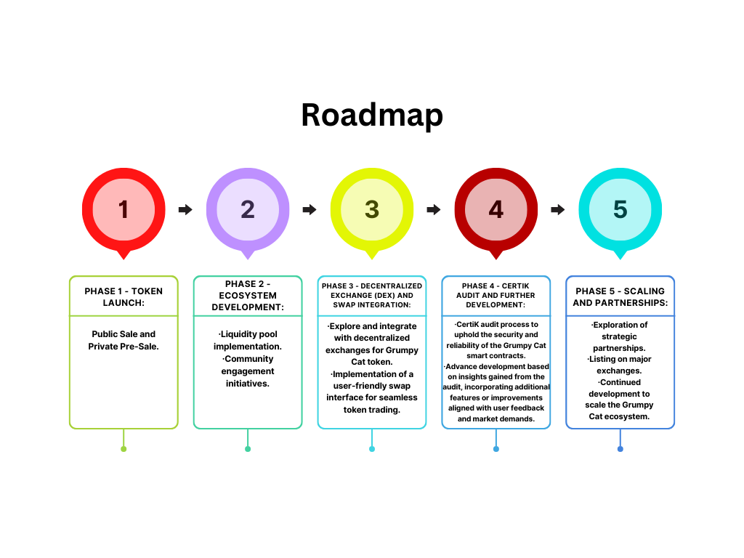

Phase 1 - Token Launch:

* Public Sale and Private Pre-Sale.

Phase 2 - Ecosystem Development:

* Liquidity pool implementation.
* Community engagement initiatives.

Phase 3 - Decentralized Exchange (DEX) and Swap Integration:

* Explore and integrate with decentralized exchanges for Grumpy Cat token.
* Implementation of a user-friendly swap interface for seamless token trading.

Phase 4 - CertiK Audit and Further Development:

* CertiK audit process to uphold the security and reliability of the Grumpy Cat smart contracts.
* Advance development based on insights gained from the audit, incorporating additional features or

improvements aligned with user feedback and market demands.

Phase 5 - Scaling and Partnerships:

* Exploration of strategic partnerships.
* Listing on major exchanges.
* Continued development to scale the Grumpy Cat ecosystem.

**Governance and DAO:**

Community governance takes center stage through the implementation of a DAO. Grumpy Cat holders actively participate in decision-making processes, with proposals subject to community voting, ensuring decentralized and transparent governance.

**DeFi Integration:**

Phase 1 - Liquidity Pool Development:

Implementation of liquidity pools, enhancing the trading experience and providing opportunities for users to stake tokens.

Integration with popular decentralized exchanges.

Phase 2 - Yield Farming and Staking:

Introduction of yield farming and staking programs, incentivizing token holders and creating additional revenue streams.

**Marketing Campaigns:**

Launch of strategic marketing campaigns to boost brand visibility and foster community engagement.

**Airdrop:**

Execution of a carefully planned airdrop campaign to distribute tokens widely, encouraging community participation and fostering wider adoption.

**Conclusion:**

Grumpy Cat is committed to establishing a vibrant ecosystem, uniting community involvement, innovation, decentralized governance, and financial empowerment through DeFi. Join us on this exhilarating journey as we bring a dose of grumpiness to the crypto world.

***Disclaimer:*** This whitepaper is for informational purposes only and does not constitute financial advice. Users are encouraged to conduct their own research before participating in any token sale.

2024 ©